Low Flow Calculator
Version 1.0.x
Copyright 1999-2002
Daniel P. Ames
Environmental Management Research Center
Utah Water Research Laboratory

Help and Information

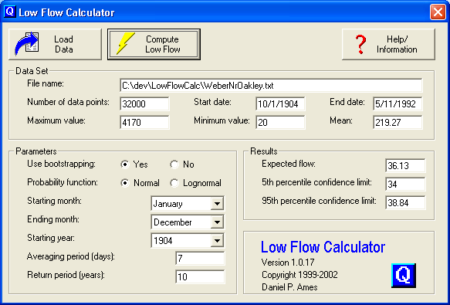

Purpose:

The purpose of Low Flow Calculator™ is to compute the expected low flow for a specified number of days with a specified return period based on a historical data set of daily streamflow.

Water quality modelers are often interested in the “7Q10” flow as a representative dry condition upon which to base model results, particularly in cases where water quality is worst during low flow periods (e.g. if it is dominated by point sources such as waste water treatment plants.) The 7Q10 flow is the yearly 7-day average low flow with a 10 year return period.

Low Flow Calculator™ can also be used to compute low flow periods other than 7Q10. For example, you can use Low Flow Calculator™ to compute the expected low flow that will occur over a two week period once every 100 years (i.e. the 100 year – two-week drought), or the one-day low flow that will occur about every 10 years.

Methodology

Low Flow Calculator™ uses two algorithms for computing the expected low flow. Each algorithm begins by identifying the lowest flow in each year averaged across the averaging period (e.g. the lowest 7-day average, if 7 is used for the averaging period). In the standard algorithm (no bootstrapping), the mean and standard deviation of the yearly low flow averages are computed. These are used to define either a normal or lognormal probability distribution from which the flow with the correct return probability is derived (e.g. the flow that has a 0.10 probability in the case of a 10-year return period).

The alternative algorithm utilizes a bootstrapping technique to generate confidence limits for the low flow estimate. This is done by identifying the yearly low flow averages as described previously. A large number of bootstrap realizations of this data set is then generated to account for the fact that the years we have are only a sample of the data. For each of these realizations, expected low flow is estimated from the selected probability distribution. Because a large number of low flow estimates have now been generated, it is possible to generate a more robust estimate of the actual low flow as the mean of the full set of estimates. Additionally, it is now possible to estimate confidence limits for the final estimate.

Graphical User Interface:

Load Data

This button loads the data set to be analyzed. Note the following requirements for importing data into this version of Low Flow Calculator™:

1) A maximum of 32,000 data points are allowed (about 87 years). If the file you are loading has more than 32,000 points, a message will notify you that only the first 32,000 will be loaded.

2) The data must consist of sequential daily values. Missing data or dates are not allowed and may give bad results.

3) The file must contain dates and flows in two comma delimited columns. The easiest way to format your data in this way is to copy two columns from a spreadsheet and paste them into Notepad and save the file. A sample input data file in the correct format can be downloaded here. (link to EastCanyonBearHollow.txt)

Compute Low Flow

This button starts the low flow calculation. If no data is loaded then this button is not functional. The parameters used in the low flow calculation are taken from the Parameters box on the GUI as described below. Note that for larger datasets, and when using the bootstrapping option, the computation may take several minutes. This version of Low Flow Calculator™ does not include a progress bar, so please be patient.

Data Set

This frame contains information about the data set that you loaded. This is provided to help you confirm that the data set is complete and was successfully loaded. Included here are: the filename that was loaded, the number of data points loaded, minimum, maximum and mean values of the data, and the start and end dates of the data.

Parameters

This frame contains the input parameters for Low Flow Calculator™. These include:
- Use bootstrapping-sets whether to use the bootstrapping algorithm. For confidence limits to be estimated, this must be set to “yes”. Note that this may increase computation time notably on large data sets.
- Probability function – sets whether to use a normal or lognormal probability distribution for the data. Streamflow typically fits a lognormal distribution better than a normal distribution.
- Starting month and Ending month – together, these inputs set a boundary for period during the year for which an estimate is required. For example to only look at summer low flows, you could set the starting month to June and the ending month to September. Some data sets may be too short to derive a valid low-flow estimate from only a portion of the full year. In these cases, and in any case when a solution cannot be found, Low Flow Calculator™ returns “-1” as the expected flow.
- Starting year – this input allows you to set a starting year for the analysis.
- Averaging period (days) – this is the number of days for which the average low flow will be computed each year. For a 7Q10 analysis, this should be set to 7. For a two-week drought, this should be set to 14. As mentioned before, if a solution cannot be found for the specified averaging period, Low Flow Calculator™ returns “-1” as the expected flow.
- Return period (years) – this is the return period for which the low flow is needed. For a 7Q10 analysis, this should be set to 10. To compute the 100-year drought, this should be set to 100. Again, a solution may not always be possible for the specified return period, given the loaded data. In this case, Low Flow Calculator™ returns “-1” as the expected flow.

Results

This frame contains the results of the Low Flow Calculator™ analysis. The expected flow for the given probability distribution, averaging period and data set is displayed as computed by either the bootstrapping or standard approach. If the bootstrapping approach is used, then the 5% and 95% confidence limits for the estimate are also displayed. Note that when bootstrapping is used, the low flow estimate will be slightly different every time you compute it. This is due to the nature of the algorithm and is a result of assuming that the data loaded is only a statistical sample. The confidence limits should be used as a guide to help you assess the result. For example, if the expected flow is 10 cfs, with 5th and 95th percentile confidence limits of 9 and 11 cfs respectively, then you can be very confident in the estimate of 10 cfs. However if the confidence limits are 9 and 100, then the estimate of 10 cfs is less reliable. This kind of wide confidence interval suggests that low flow values are not consistent across years and may be evidence of changes in stream management, or natural climate variability.

About Low Flow Calculator™

Low Flow Calculator™ was programmed in Microsoft Fortran Powerstation 4.0 and Microsoft Visual Basic 6.0 by Daniel P. Ames. Copyright © 1999-2002.

